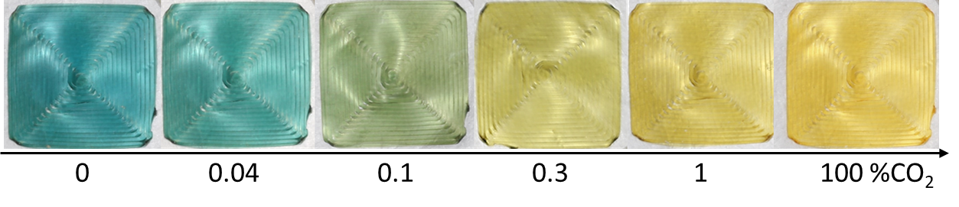



#663e2b

#6c412e





#5b3727

#613a29





#503022

#553324